FB70 -

Functionality
This transaction allows entering customer invoices. It creates postings in Accounts Receivable Sub Ledger and also updates the GL Accounts

Scenario
Most of the invoices are generally issued through SD module. However, it is possible to post a Customer Invoice in FI module. It can be used to post the invoices issued in case of claims against damages caused by site contractors, selling used furniture, insurance claims etc.

Requirements
Issued customer invoice

Menu Path | Accounting → Financial Accounting → Accounts Receivable → Document entry → FB70 - Invoice
Transaction Code | FB70
1. Double click on FB70 – Invoice.

Enter customer invoice: Company code 5200

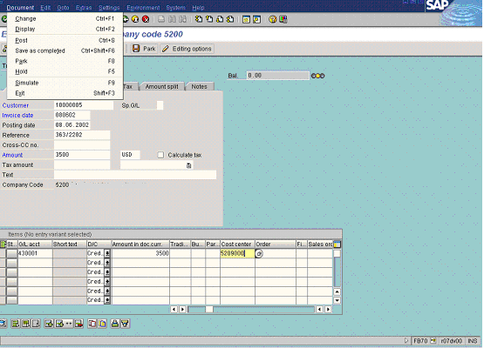

2. Update the following fields:

Field Name | Field Description | Values
Customer | Code identifying a customer account | Example: 10000005
Invoice date | Date when the invoice was issued | Example: 080602
Reference | Reference document number | Example: 363/2202
Amount | Amount of the invoice | Example: 3500
G/L acct | GL Account number | Example: 430001
Amount doc.curr. | Amount of the line item | Example: 3500
Cost center | Code identifying an organizational unit to which costs or assets are assigned | Example: 5209000
.
3. You need to check the payment details. To do so, click <tab button> Payment . Some payment details will be populated from the Customer Master (like payment terms and a payment block), but you can change it if necessary.

Enter customer invoice: Company code 5200

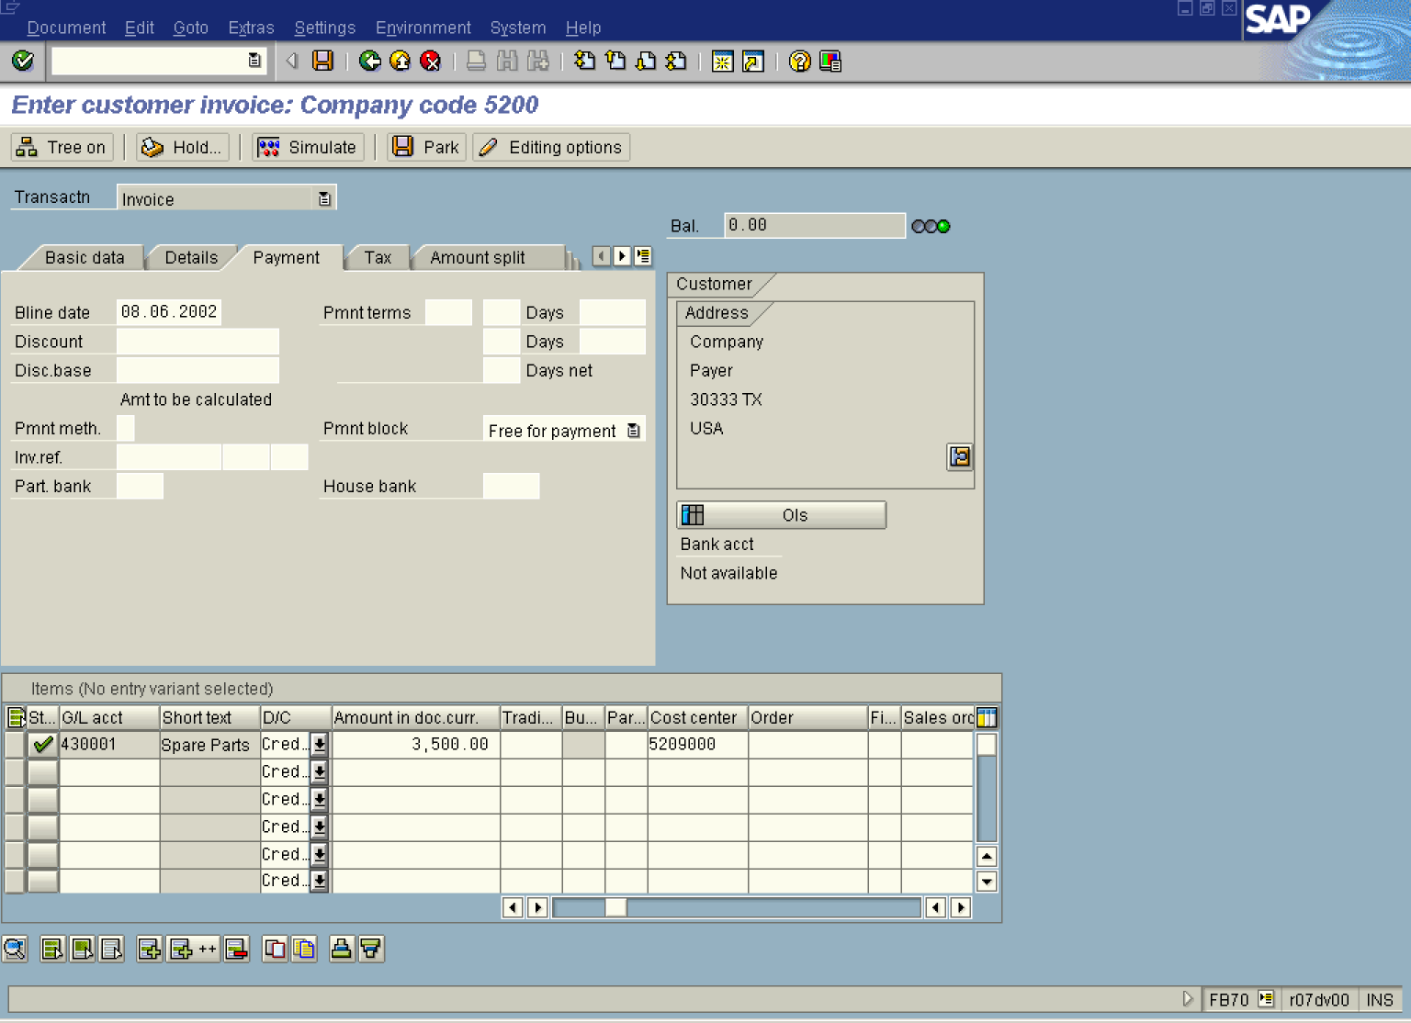

4. Go to the field “Pmnt terms” and Press [F4] or click the button in the Pmnt terms field. The system will display the list of terms of payment that are defined for the customers:

Terms of Payment

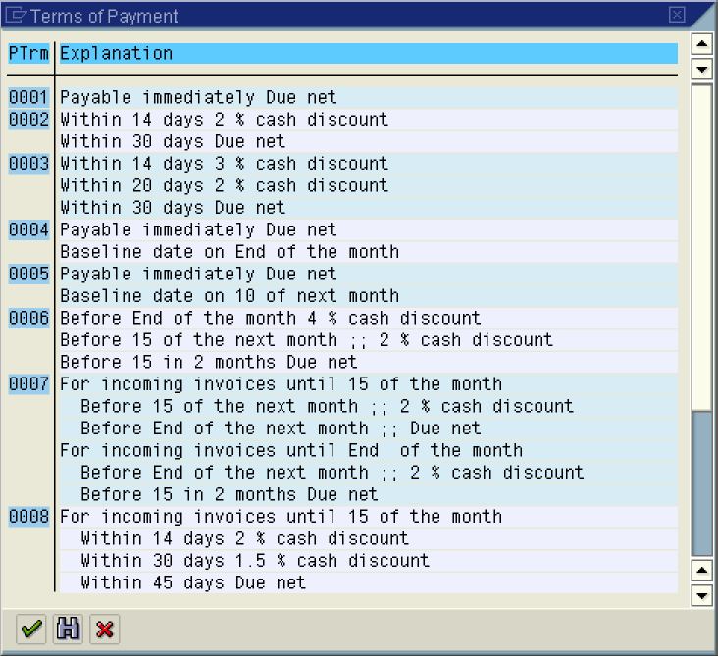

5. Select the correct payment term being the agreed term with the customer for this transaction.

Enter customer invoice: Company code 5200

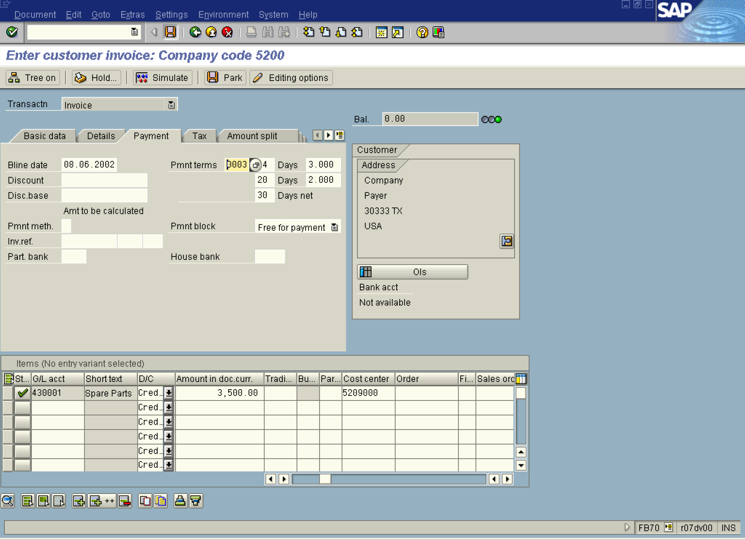

6. Click Enter Button.

7. To display a document before posting it, select DocumentSimulate from the menu path:

Document Overview

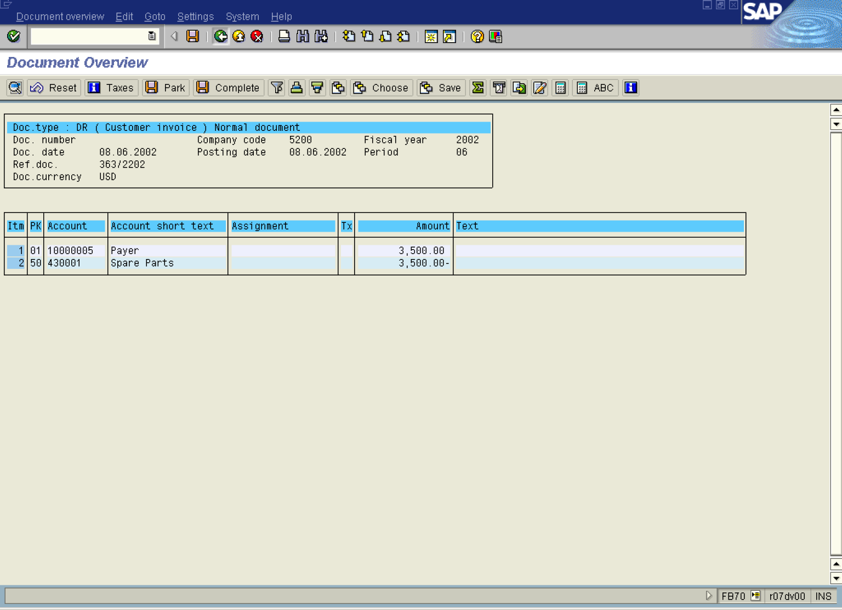

8. To post the invoice, click Save Button..

